**K8S Network Policy**

Flannel do not support Network Policies

INGRESS

Pod & namespace selector

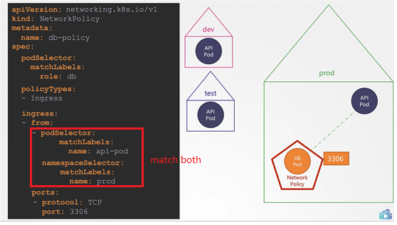

Ip selector

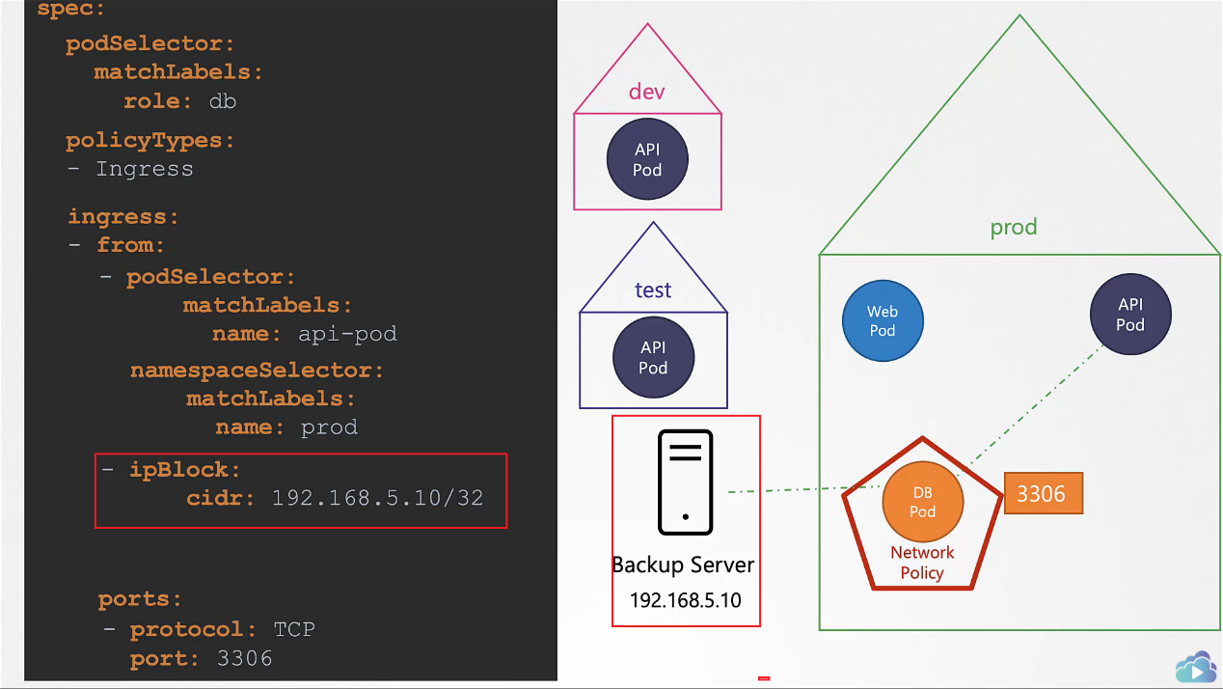

EGRESS

